## **Lab Exercise 1 CLI Commands**

1. Create a new folder

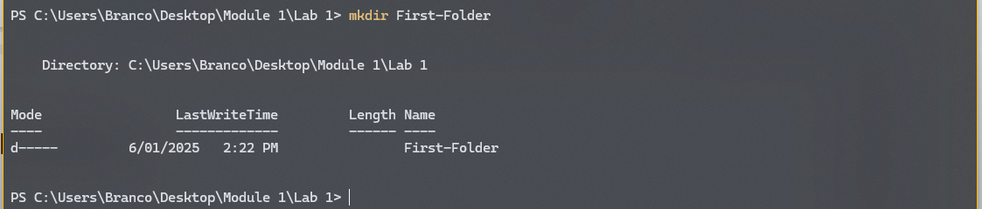

1. Create another folder inside the first one

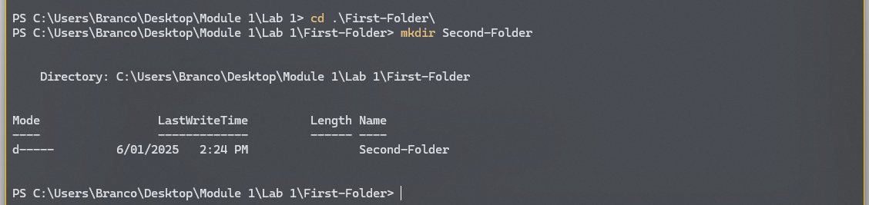

1. Print the contents of the first folder

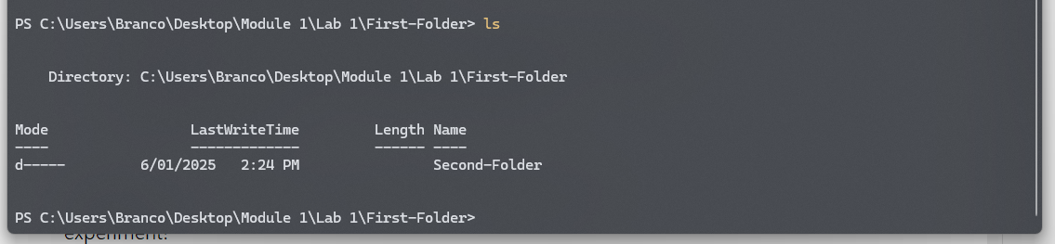

1. Change directory to the second folder, and print the current path

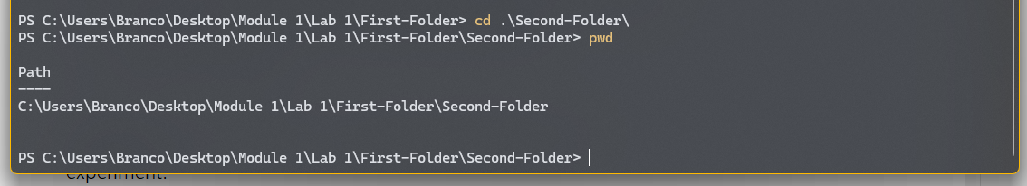

1. Change directory back to the original starting place



1. Delete the first folder

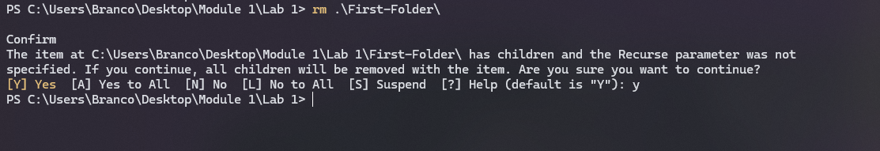

**Extension:** Research the cp, mv, cat and find commands, and

experiment!